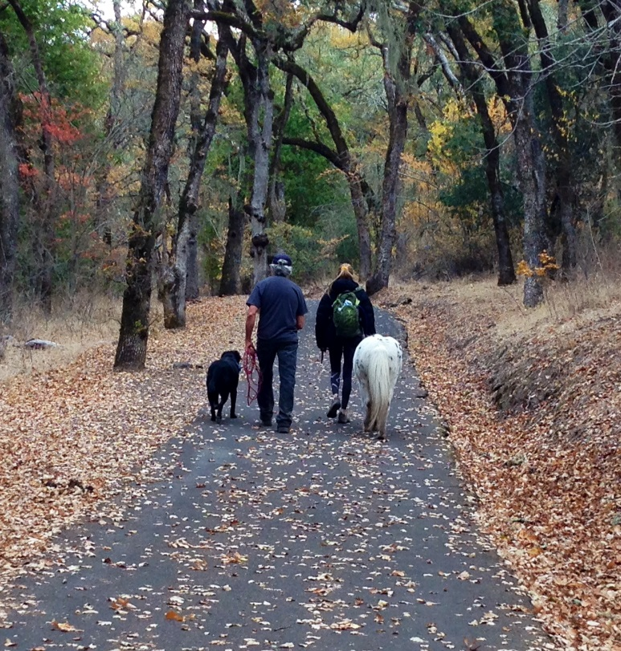

Family Reunification Workshop
“A Time for Families”
Revised 9/18
A case-specific, solution-focused opportunity
for families to connect, reconnect, and heal.

Overview:

The Transitioning Families is a group of independently licensed mental health practitioners working collaboratively. The Transitioning Families Therapeutic Reunification Model (TFTRMTM), originally conceptualized by Rebecca Bailey, PhD in 2006, and further developed by Cynthia Psaila, LMFT and Jane Dickel, LCSW at the Transitioning Families Program in California, is an experiential, educational, solution-focused approach to healing families. The breadth of reunification treatment within this model includes families experiencing high conflict divorce, families facing reunification post-abduction or major trauma, and blended families wanting to enhance their transition.

The TFTRM™ approach is case specific and based on intervention guidelines for responding to child abduction developed by the Department of Justice (Berhman-Lippert & Hatcher, 2000, DOJ, 1992). The founding clinicians have expertise with family systems therapy, advanced training in animal assisted therapy, and a forensic specialization with families in high conflict, court involvement, and post-trauma. For a more comprehensive description of the model see page 232-249 of the Family Court Review Journal, Volume 54, Number 2, April 2016.

This is a case-specific, solution-focused approach originally designed for Reunification after non-familial abduction/alienation/estrangement cases – situations when a child(ren) is having significant difficulty in managing the relationship with one or both parents during or after a separation or divorce. The workshop is not a fact finding blame-focused intervention. Nor is it a custodial evaluation. Instead, it is an alternative to traditional interventions for families that are seeking ways to connect, break down barriers between family members, and repair existing or past difficulties.

Why Choose This Workshop:

Largely unique to this reunification model is the onsite intensive structure; the combination of intellectual, emotional, and physical participation by the family members; and the integration of equine, recreational, and culinary intervention with traditional talk therapy. The program draws from evidence based interventions in brief and strategic, solution-focused, and cognitive behavioral therapy in the design and implementation of the program. Additionally, onsite equine assisted interventions facilitate a dynamic environment that few families have the chance to encounter. Equine interventions are tailored to address a variety of needs within the family including, but not limited to, parenting skills, teamwork, and self-confidence. ‘Horse-work’ transcends rigid and limiting defense structures with the family system and allows for profound insight and healing opportunities.

Enriched by the ‘here and now’ process, the TFTRM™ nurtures continued growth beyond program parameters. With its’ psychodynamic foundation and its’ broad tool set of techniques, the program is able to build bonds from within the family structure in the most complex of scenarios and situations.
Who Should Participate?

Many of the cases that come to us are families we term “Complex Case Scenarios” embroiled in scenarios as difficult as reunifying post familial abduction, child/parent contact refusal and resistance, and other challenges to family health. Families that have been estranged or distanced from each other by everyday life challenges, by crisis, or an intense conflict are excellent candidates for participation. While many participants are Court referred cases, some families use the workshops to strengthen family relationships across single or multiple generations. Some are self-referred, referred by mental health providers or agencies, or other agencies (i.e. The National Center for Missing and Exploited Children, Victim Compensation/Advocacy Programs, or local and federal law enforcement). Families enter the program at various points in their challenging situation depending on their specific needs. What we have discovered is that families can thrive even in crisis when offered a multi-faceted, strength-based family systems approach to crisis, conflict, or challenge.

Some of the possible scenarios include, but are not limited to: high conflict divorce; casualties of manmade or natural disasters; familial and non-familial abductions; returning military; survivors of violent crimes; and families simply looking to connect or reconnect with each other.
Because of the case specific nature of intervention, each family will have a different treatment plan. All members may be asked to participate. In some cases this may include extended family members.

High Conflict Divorce:

Therapeutic reunification in these types of cases employs a non-blaming, solution focused, case specific model for restoring and reunifying relationships between children and parental figures. These situations often exhibit some element of child contact refusal or resistance. In these cases the focus is on the repairing and healing of fractured bonds within the family.

Goals and Objectives:
- To reduce the conflict between the children and each of the parents to allow for healthier relationships.
- To facilitate, repair, and strengthen child relationships with both parents.
- Help family and children untangle difficulties created or worsened by court involvement.
- Help children rebuild a relationship with longevity with both parents.
- Encourage and foster a working relationship for the entire family by promoting a balanced perspective and an inclusive solution-focused perspective.
- Strengthen compassion and communication skills.
- Help empower both parents to be effective parents.

Familial Abduction:

Ironically, as the custody laws have become more equitable, situations where one parent illegally takes custody of the child or children are increasingly more common. Custody rulings vary from state to state, from courtroom to courtroom, leaving desperate parents confused regarding their custodial rights. Familial abduction can occur because of anger, retribution, or frustration between parents. Equine assisted exercises can promote a reconnection process for the whole family and provide a pathway for resolving feelings, enhancing communication and discovering other issues in need of attention.

Non-Familial Abduction:

These cases present a particular challenge in that the experiences of the abducted individual and those of the family left behind can be vastly different. This might also be true in familial abductions, but is a near certainty in stranger abductions. In cases of non-familial abductions, one of the first orders of business is to facilitate a common ground with the family unit. For example, a love of animals can be a deep connection the family shares. A long forgotten family recipe cooked and served together can quietly awaken a shared memory We find that following a stranger abduction the central victim is likely to exhibit an absence of emotion. Talk therapy can be threatening and confusing to all the participants. Therefore, work in the horse arena can be easier for the clients and more palatable for all family members, thus more productive for all concerned.

Goals and Objectives:
- Encourage and foster a working relationship for the entire family by promoting a balanced perspective and an inclusive solution focused perspective.
- Help families untangle difficulties caused by the abduction.
- Strengthen existing familial relationships and promote and support the development of compassion and communication skills.
- Strengthen empowerment of the family in the face of external interference from extraneous well-meaning agencies such as courts, media, and community organizations.

Foster Families, Military Families, and Others:

Reunification work can also include foster family reunification services between the child and the foster parent or the child and the parent(s) of origin. Intensive reunification services are short term. Intensive family-based sessions are designed to reunite children with parental figures. It is the intent that the work will be continued with community based mental health professionals. In some cases, workshops for disengaged families can be useful and warranted. The disengagement can be due to geographic distances for reasons such as life choices and military deployment.

Risks of Treatment:

Crisis creates vulnerability. All of the therapists connected to the Transitioning Families team are acutely aware of this issue. Every effort is made to empower the family make their own decisions and to create options for them to choose from. Informed consent is an important component to the work of Transitioning Families. These choices are a crucial part of the treatment regardless of the stage of the reunification process.

The interventions and activities chosen for each family allow for options in the depth of interpretations made by the families. For some families cooking, horse work, and hiking are merely activities to connect, while others see it as a vehicle for development, growth, and self-awareness. Each family sets the tone for the reunification or transitional work. In the case of multiple perspectives in a family, the focus becomes finding the common theme for all of the family members.

It is possible that the work can reveal hidden issues that are distressing to one or more of the family participants. In some cases the issues can be addressed in the context of the Transitioning Families reunification workshop. In other cases, adjunct work with existing therapists or referrals to new therapists or agencies can be an important component for ongoing growth.

Intake, Assessment and Referral:

All cases begin with an Intake Assessment for the appropriateness of the referral and for the suitability for various types of interventions. Possible interventions are identified, and considered, with known risks and benefits for each as well as the risks and benefits of no intervention. Our recommendations may include:
- Our highly innovative experiential/educational workshop for families incorporating experiential and equine-assisted growth and learning techniques.
- An alternative workshop, which does not include an experiential element.
- We also, depending on the circumstances, can offer weekly sessions with the child and least favored parent with a focus on reunification.
- Referrals for Custodial Evaluations.
The family members are made aware of our recommendations and are required to sign an Informed Consent to Treatment for any services to be provided by Transitioning Families.

Aftercare:

Part of our intake process will include determining what services you are currently using in your local area. Every effort will be made to coordinate our work with the work that is already in place (with appropriate releases). If a family has not connected with local services, every effort will be made to assist you with that.

Generally, a family will leave our workshop with a list of specific issues to work on and suggestions to follow. These will be shared with your community resources as you choose. There are several options for follow-up with Transitioning Families after your departure:
- Periodic phone/email contact to review your progress.
- Contact with your local service providers for continuity of care.
- Another intensive weekend to continue work completed in the first workshop
- Case specific flexible arrangements as needed.
- Case management services through Transitioning Beyond.

Transitioning Families will make referrals to other agencies/professionals as appropriate.

Location of Workshops:

Our program workshops are located primarily in Sonoma County, California. Arrangements can be made to bring the program to other locations throughout California and, in some cases, to other states. Contact The Transitioning Families office for more information.

Duration:

Ideally, workshops are three and a half days to five days, but can vary in duration depending upon the clinical needs of the family, availability of participants, logistical issues, or time constraints. The schedule of each workshop is agreed upon in advance with an eight-hour day being the norm. The overall costs for the workshop is arranged prior to the start of the program.

Accommodations:

Most meals are prepared in cooking classes with chef and his support staff or are brought in from local restaurants. All participants are expected to stay in the area at the discretion of the TF staff. Travel arrangements and lodging expenses are the responsibility of the participants. A workshop administrator is available to assist in the logistics of travel and lodging

Registration and Scheduling:

For more information about “A Time for Families” workshops, scheduling, and registration fees, please contact the Transitioning Families office at (707) 237-5330 or email to admin@transitioningfamilies.com.

Sample Workshop Outline:

The workshop consists of a series of educational sessions, discussion groups, and experiential exercises – some of which utilize horses in an equine-assisted growth and learning model. Each day we will begin with a combination of these, with a break for lunch followed by another combination of these in the afternoon. Dinner arrangements vary according to our assessment of the needs of each family on that day. It may be prepared for, with, or by the family. Supplies are always provided unless otherwise stated. Evening activities are suggested and sometimes may include a staff member. The issues dealt with for each family will vary, however a general outline is as follows:

Day One:
- Workshop Orientation: Educational/experiential session addressing our case specific approach and the non-blaming focus.
- Identifying core issues: We want to identify many of the ‘elephants’ that have been in the family’s home while remaining mindful, purposeful, and authentic.

Day Two:
- Exploration of family system: Discussion and experiential/educational exercises designed to encourage exploration of perspective, perception, and communications. This may include the preparation of a timeline of family events as perceived by the children with input from the parents.
- New language: We generally develop a system of language with the family that is pro-relationship. Key words may include trust, honesty, compassion, courtesy, respect, attunement, and humor. We also identify with the family anti-relationship patterns that are to be avoided. These may include threatening, disrespect of boundaries, sarcasm, and litigation.

Day Three:
- Communication and Cooperation: Utilizing a variety of experiential components, including equine-assisted growth and learning exercises, arts and crafts, recreation and outdoor activities and educational culinary experiences, we focus on communication and working together. Using the words and language that we developed on Day Two, we begin to problem solve and develop a family plan which can serve as a template for the family to continue their efforts after the weekend workshop.

Day Four:
- Skills Learned: The final group session features exercises and activities that focus on skills learned during the weekend.
- Plan: The final meeting is for sharing the prepared outline of the aftercare plan and for ongoing support suggestions.

The Transitioning Families Program, founded by Rebecca Bailey, Ph.D.

Transitioning Families encompasses an intense therapeutic reunification program, outpatient reunification services, training seminars for health professionals, parent coordination, and options for therapeutic supervised visitation. Dr. Bailey has specialized for nearly 20 years in working with high-conflict familial situations. She was formerly the Director of Youth and Family Services for the Sonoma Police Department, co-director of teen outpatient drug and alcohol substance abuse program, and a therapist educator for the Marin Community Resources Center and the Marin County DUI program. Well-grounded in childhood development theory, her background also includes six years in preschool education. She has served as a Parent Coordinator for divorcing families and has developed parenting classes and solution-focused interventions for families experiencing all types of conflicts. She is an active member of the American Association of Family and Conciliation Courts (AFCC) and a consultant to The National Center for Missing and Exploited Children (NCMEC). In 2009, working with NCMEC, Transitioning Families came to national recognition due to a highly publicized case. In 2013, Dr. Bailey and her sister Elizabeth Bailey co-authored the book, Safe Kids, Smart Parents.

As founder of the Transitioning Families Program, Dr. Bailey has comprised a team of experienced professionals. On site, intensive, reunification weekend workshops can include Psychologists, Clinical Social Workers, Marriage and Family Therapists, recreational specialists, an educational chef, an equine professional, an art teacher, interpreters, and trained support staff.
Each team member has extensive experience working with a variety of challenging families. Together we share the ultimate goal of assisting families in transitioning them from crisis, challenge or conflict to connection and growth.

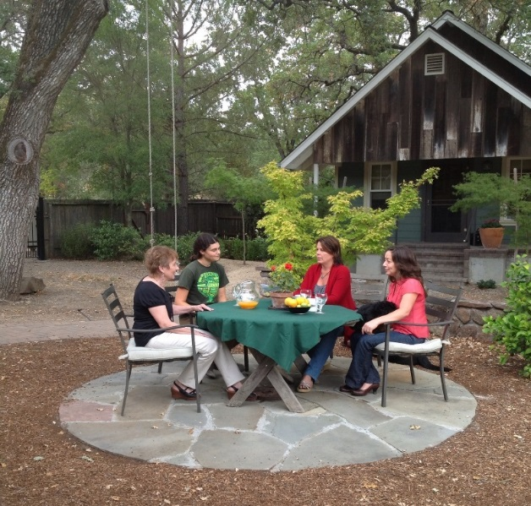
The diversity of our experience has led us to the assumption that although traditional therapeutic techniques have a place, there are other psycho-educational and experiential methods that help families grow and thrive. The team clinicians have strong psychodynamic therapy backgrounds which they use in a more direct psycho-educational even didactic approach. Additionally, the Team maintains consulting relationships with a variety of seasoned professionals. Tailored to meet the individual needs of each family, the Transitioning Families Therapeutic Reunification Model (TFTRM™) provides on-site intensive weekend workshops. In addition the Team also provides certain program services nationwide assisted by an intensive response team. The combination of efficacy and creativity embodied by Dr. Bailey and the Transitioning Families team of professionals allows treatment across a variety of populations irrespective of cultural geographic, and economic differences.

